Switch language to Intermediate Student with lambda



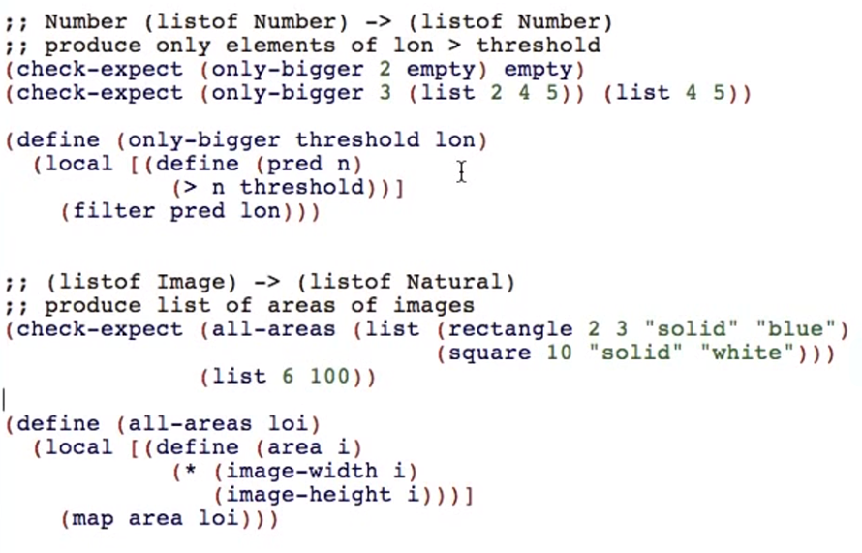

The locally defined function is:

* Only used in one place
* The body is so easily understood that naming the function doesn’t make the code easier to understand

We can rewrite those functions in a different way:

Copy this part of the function

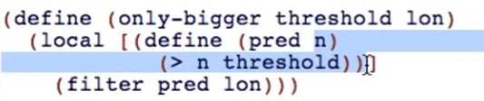

Go to “pred” (the function you defined in that body)

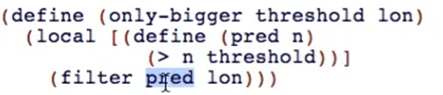

Use lambda primitive

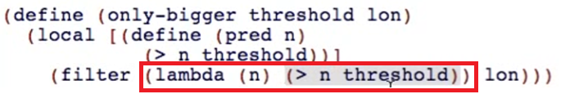

Get rid of the local



Comment out the original code

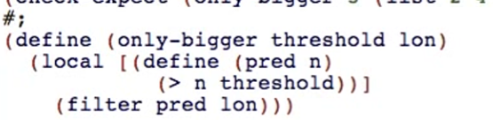

Run and check if still passing

What happened here:

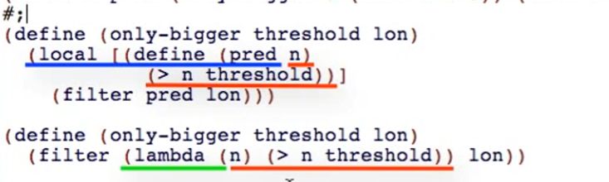

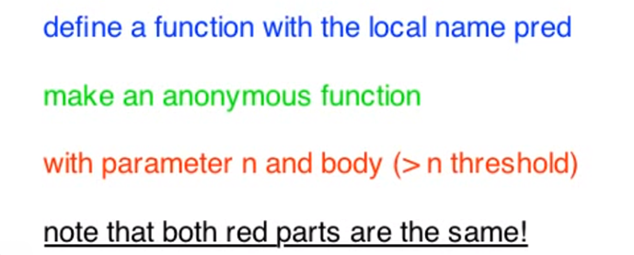

Lambda let’s you define an anonymous function

* Makes you simplify your code
* As long as these criteria passed:

The locally defined function is:

* Only used in one place
* The body is so easily understood that naming the function doesn’t make the code easier to understand

You can also type lambda like this:



Use Ctrl+\ (backslash)